# COMPUTER SCIENCE & ENGINEERING



## Experiment - 1.3

**Student Name:** Nabha Varshney **UID:** 20BCS4995

**Branch:** B.E(CSE) **Section/Group:** 20BCS704-A

**Semester:** 6th **Date of Performance:** 28-02-23

**Subject Name:** Internet of Things Lab **Subject Code:** 20CSP-358

## Aim:

Demonstration of Autodesk Tinkercad Simulation Platform.

## Objective:

1. Learn about IoT based simulations.
2. Testing and model in IoT based simulation platform.

### Introduction of Tinkercad:

**Tinkercad -** It is an excellent tool that allows you to simulate Arduino-based systems (and a lot more). You can (perhaps you SHOULD) simulate all exercises and even your own designs before trying them on real hardware. It also allows you to do programming using blocks. You can download / copy-paste the generated code later into Arduino IDE to program the real Arduino board, rather than having to write it from scratch.

Create a new personal account on Tinkercad website (you can also use your Google account to log in). Then select Circuits on the left pane, and click Create new Circuit.

### Hardware:

In Components Basic, you can select Arduino Uno R3.

# COMPUTER SCIENCE & ENGINEERING



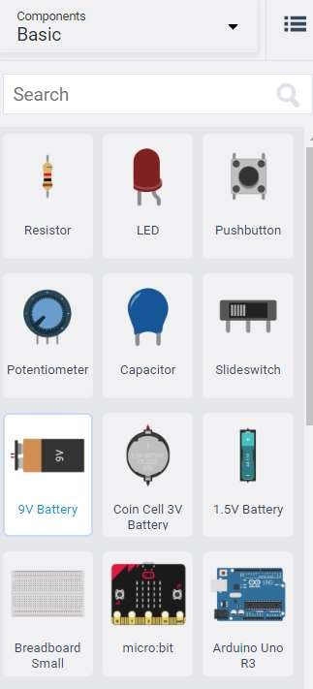

You can add more components and wire them up as desired. Clicking on the lead of a component allows you to start a connecting wire from there. Clicking on a wire allows you to change its color.

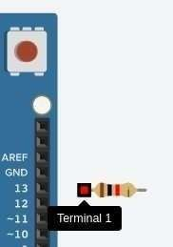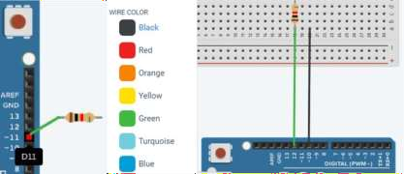

### Programming and Simulation:

To program the Arduino,

1. Click on Code
2. You can choose Blocks or Blocks + Text or Text*. For beginners, it is recommended to use **Blocks + Text**.
   1. This allows you to see the C++ code generated corresponding to your blocks.
   2. You can copy this code later into Arduino IDE to program the real Arduino, rather than having to write it from scratch.
   3. You can also download the code as an Arduino-compatible .ino file.
3. You can code by selecting the blocks and connecting them appropriately.
4. You can start the simulation by clicking Start Simulation.

*Note: You can go between Blocks and Blocks + Text anytime. You can go from Blocks / Blocks + Text to Text, but you can't go back from Text to either of the other two (converting blocks to text is easy, converting text to blocks is computationally non-trivial).

You have to click Stop Simulation to stop the simulation before you can modify your program and/or hardware connections.

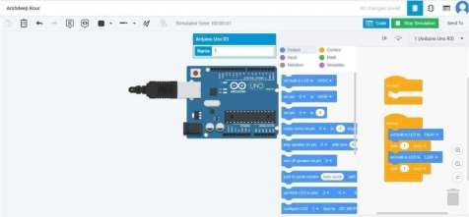

### OUTPUT:

**Connection:**

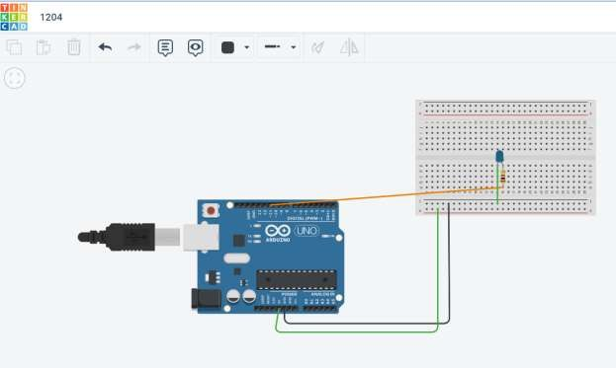

### Code:

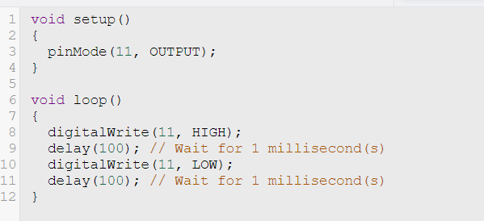

**After Simulation:**

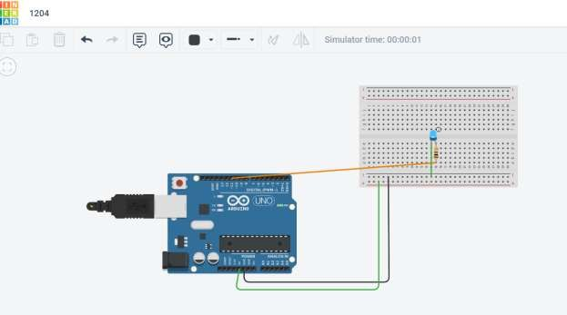

### Learning Outcomes:

1. Basic 3D modeling skills: Users can learn how to create basic 3D shapes, and how to combine and manipulate them to create more complex designs.
2. Understanding of technical specifications: Tinker cad provides a wide range of technical specifications such as dimensions, tolerances, and clearances that users must understand and apply to their designs.
3. Simulation skills: Tinker cad allows users to simulate their designs, which means they can test the functionality of their design before printing it. This helps users to identify potential problems and make necessary changes.
4. Troubleshooting: If the simulation doesn't work as expected, users can troubleshoot and fix the problem. This requires an understanding of the software and the technical specifications.
5. Design optimization: Tinker cad provides users with tools to optimize their designs. This can include things like reducing weight or material usage, improving stability, or increasing strength.